|  |  |
| --- | --- |
| Graphical user interface  Description automatically generated  Assignment 2  ITRI 613 | Enrico Dreyer  31210783 |

Table of Contents

Table of Figures 1

Part 1 2

Unique features and characteristics of different RDBMS 2

Why RDBMS is better that DBMS 2

Part 2 3

Question 1 3

Question 2 3

Question 3 3

Question 4 4

Question 5 4

Question 6 4

Question 7 5

Question 8 5

Question 9 6

Question 10 6

One-to-one 6

One-to-many 6

References 7

# Table of Figures

Figure 1: RDBMS and their advantages 2

Figure 2: What makes RDBMS better than DBMS (Academy 2019) 3

# Part 1

RDBMS stands for “Relational Database Management system” and is a DBMS that is specially build for relational databases. RDBMS is a subset of DBMS. There are different RDBMS, things that set them apart and what their biggest advantages are of using them (help 2021).

## Unique features and characteristics of different RDBMS

|  |  |
| --- | --- |
| RDBMS | Advantages and differences |
| Microsoft SQL Server | High security features, has a variety of versions and has cloud based support (G2 2021).  Installation is easy and has a lower cost of ownership (Nagy 2018). |
| MySQL | MySQL is open source, which means it is free to install (G2 2021).  On demand scalability and round-the-clock uptime (Branson 2016).  I has very simple syntax and is not very complex. |
| Oracle Database | Customers have lower IT costs while having a higher quality of service (G2 2021).  Easy point-in-time recovery and multiple database support (Singh 2020).  It has very strong documentation and tech support. |
| IBM DB2 | Easy to deploy and can easily integrate with many platforms (G2 2021).  It has a built in task scheduler that can prioritizing and run multiple jobs at the same time (AHMED 2019). |
| Amazon Aurora | Combines the speed and quality of high-end databases while being open-source (G2 2021).  Amazon Aurora has great availability and durability, and replicates the database between multiple availability zones (Flair 2020).  It is great for small companies that a need high-end database. |

Figure : RDBMS and their advantages

## Why RDBMS is better that DBMS

|  |  |  |
| --- | --- | --- |
|  | RDBMS | DBMS |
| Storage | Stores data in the form of tables. | Stores Data a file. |
| Data Redundancy | Data redundancy is removed by using more constraints and normalization than the DMBS. | Data redundancy is present. Still better compared to the file system. |
| Modification of Data | Because data redundancy is not present it is easy to make changes, there is only needed to change the value at one place. | Because of data redundancy, modifying the data is more difficult, because you need to change the value at different places. |
| Data Relationship | Data is stored in the form of tables that have relationships with each other, with the help of foreign keys. | Data is stored with no relationship between the data. |
| Number of users | Supports multiple users at a time, users can work concurrently on the same thing. | Supports only single user at a time. |
| Data Access | Data is accessed faster. Because of data being provided in tubular structure and SQL is used to retrieve the wanted data. | Data is accessed slower. |
| Support of distributed Database | Supports a distributed database. RDBMS is located in different placed in the cloud. | Does not support distributed data. DBMS is located in a specific location. |
| ACID properties | Follows the ACID (Atomicity, Consistency, Integrity and Durability) principles. Thus, the data is consistent. | Does not have to follow the ACID properties and created inconsistencies in data. |
| Ideally Suited for | Designed to handle larger amounts of data. | Mainly deals with small amounts of data. If we use large amounts of data, the performance is slower than the RDBMS. |

Figure : What makes RDBMS better than DBMS (Academy 2019)

# Part 2

## Question 1

Select * from genre;

## Question 2

Drop table Artist;

## Question 3

CREATE TABLE AlbumSales (  
ArtistId *int* FOREIGN KEY REFERENCES Artists (ArtistId),

AlbumId *int* FOREIGN KEY REFERENCES Artists (ArtistId)*,*  
NumberofSales *int*,  
Genre *varchar(255),*

Primary Key (ArtistId, AlbumId)  
);

## Question 4

select * from Albums where year(DateReleased) = 2020

## Question 5

CREATE TABLE Albums (  
AlbumId *int*,  
AlbumName *varchar(255)*,  
DateReleased *DateTime,*

ArtistId *int PRIMARY KEY*  
);

Depending on how the table Genre is set up, it will either throw an error because there is a relationship between the two entities, or all related rows in the genre tables will be deleted (on cascade delete).

The 4 options are No Action, Cascade, SET NULL or SET Default. Depending on the child table.

## Question 6

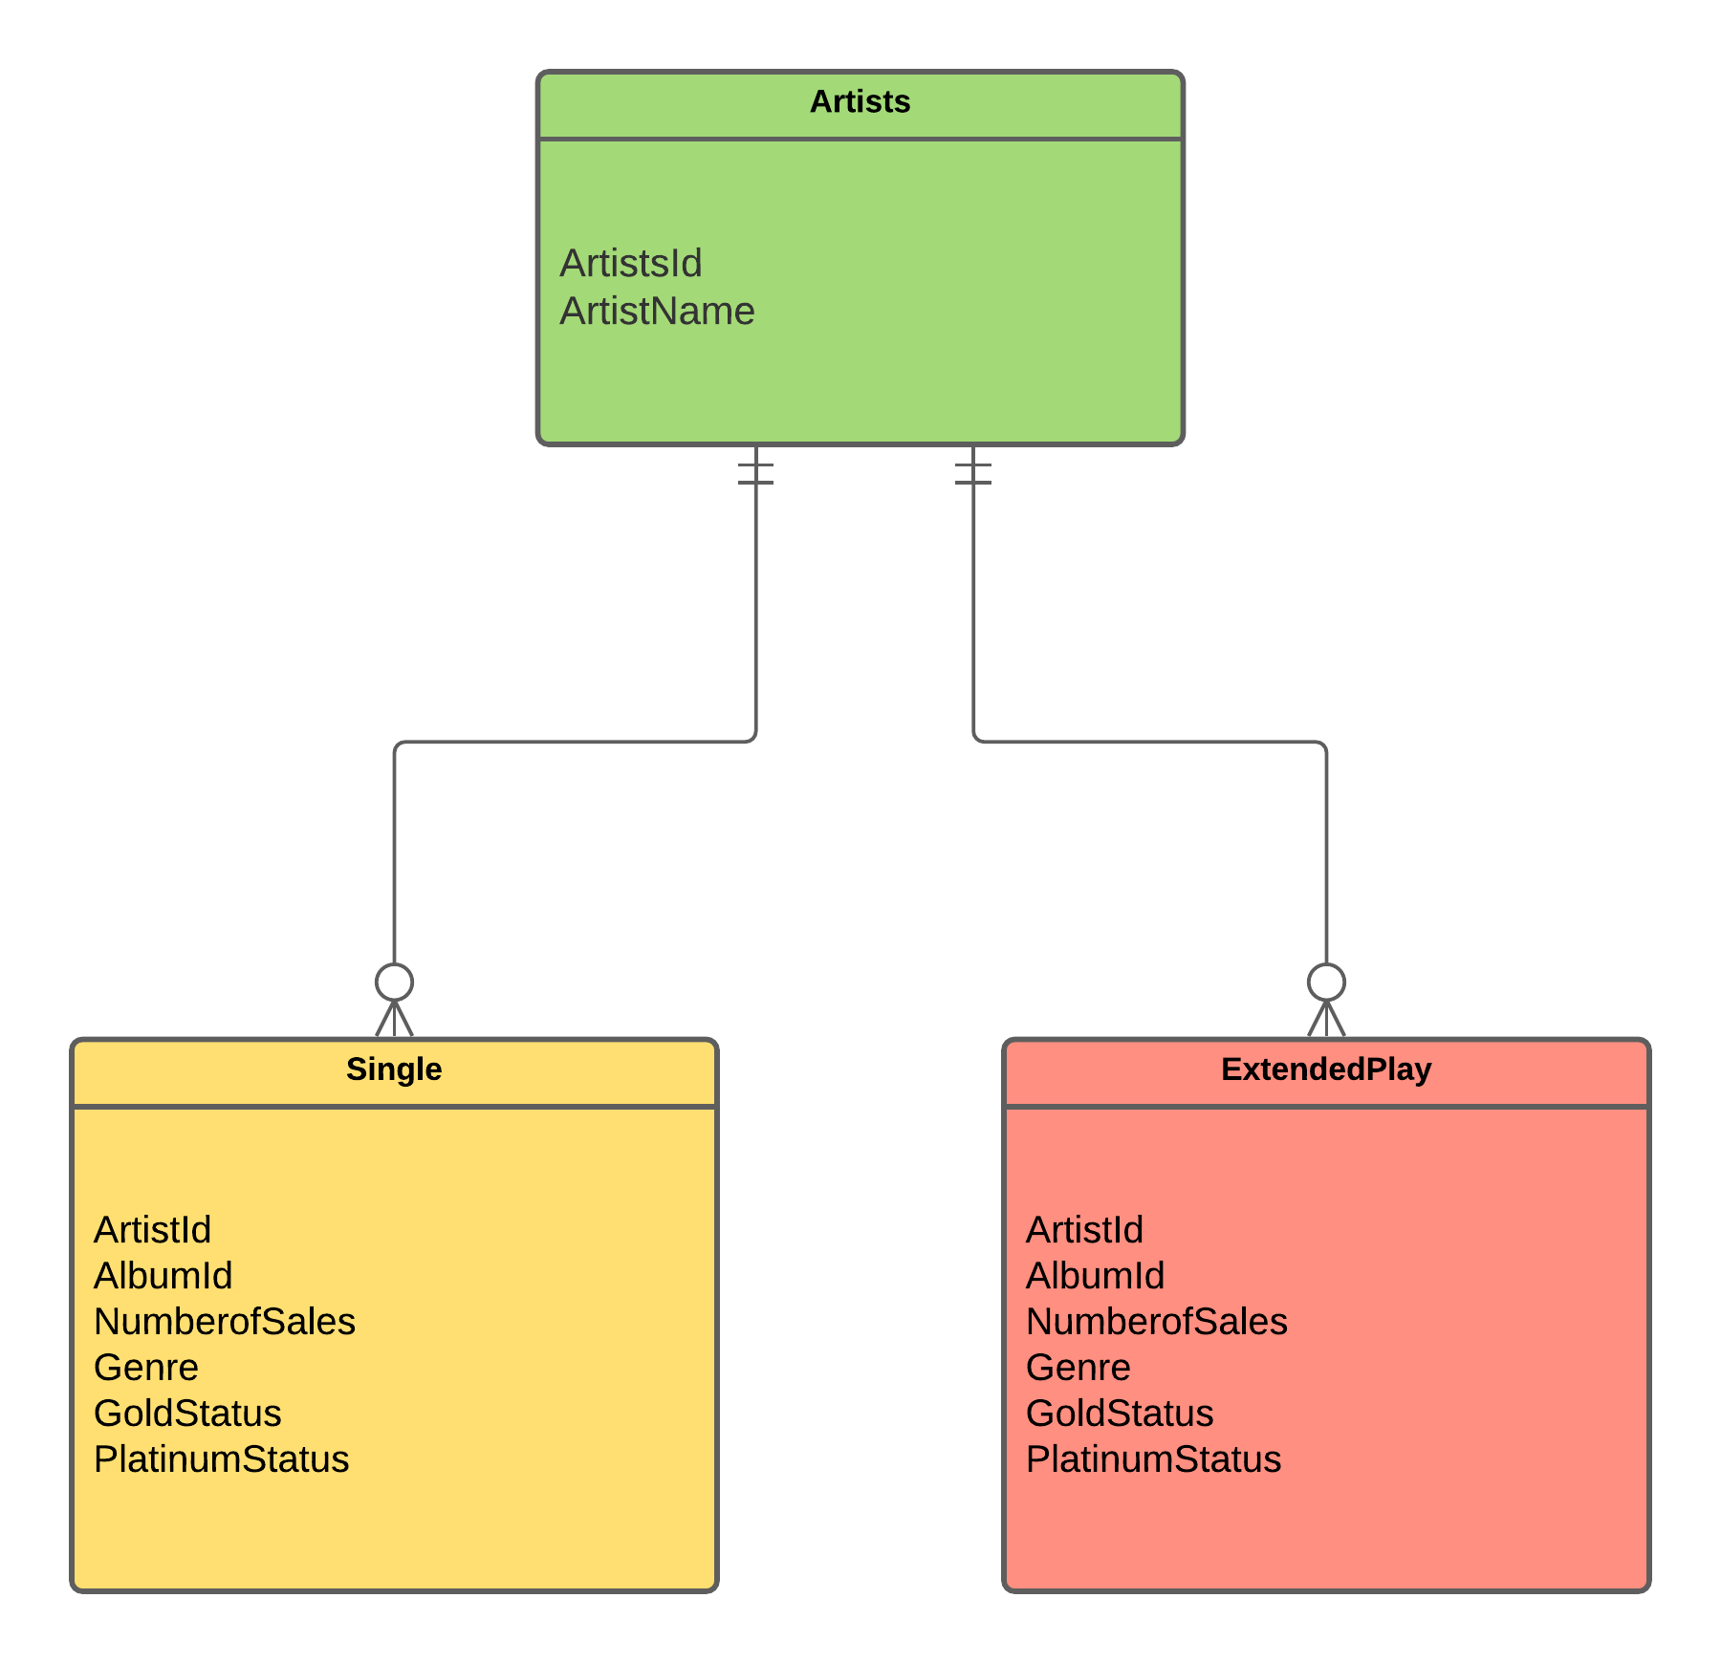

An overlapping constraint happens when the same entity contains two subclasses. In this example the artists entity can be split up into two entities names single or extendedPlay.

## Question 7

CREATE TABLE AlbumSales (  
ArtistId *int* FOREIGN KEY REFERENCES Artists (ArtistId),

AlbumId *int* FOREIGN KEY REFERENCES Artists (ArtistId)*,*  
NumberofSales *int*,  
Genre *varchar(255),*

Primary Key (ArtistId, AlbumId)  
);

CREATE TABLE Albums (  
AlbumId *int,*  
AlbumName *varchar(255),*

DateReleased DateTime,

ArtistId int FOREIGN KEY REFERENCES Artists (ArtistId),

GenreId int FOREIGN KEY REFERENCES Genre (GenreId),

PRIMARY KEY (AlbumId),   
);

CREATE TABLE Genre (  
GenreId *int*,   
Genre *varchar(255),*

Primary key (GenreId)  
);

CREATE TABLE Artist (  
ArtistId *int*,   
ArtistName *varchar(255),*

Primary key (ArtistId)  
);

CREATE TABLE ExtendedPlay (

EPId *int,*  
ArtistId int FOREIGN KEY REFERENCES Artists (ArtistId),

DateReleased DateTime,

Genre *varchar(255),*

PRIMARY KEY (EPId),   
);

## Question 8

There would be a one-to-one relationship with Albums, because one album will have one record sales. AlbumId will be the foreign pointing to Albums.

## Question 9

CREATE VIEW [Artists View] AS  
SELECT *   
FROM Artists

## Question 10

### One-to-one

* RecordSales and Albums
* RecordSales and Artists

### One-to-many

* Albums and Genre
* Albums and Artists
* Artists and single
* Artists and ExtendedPlay

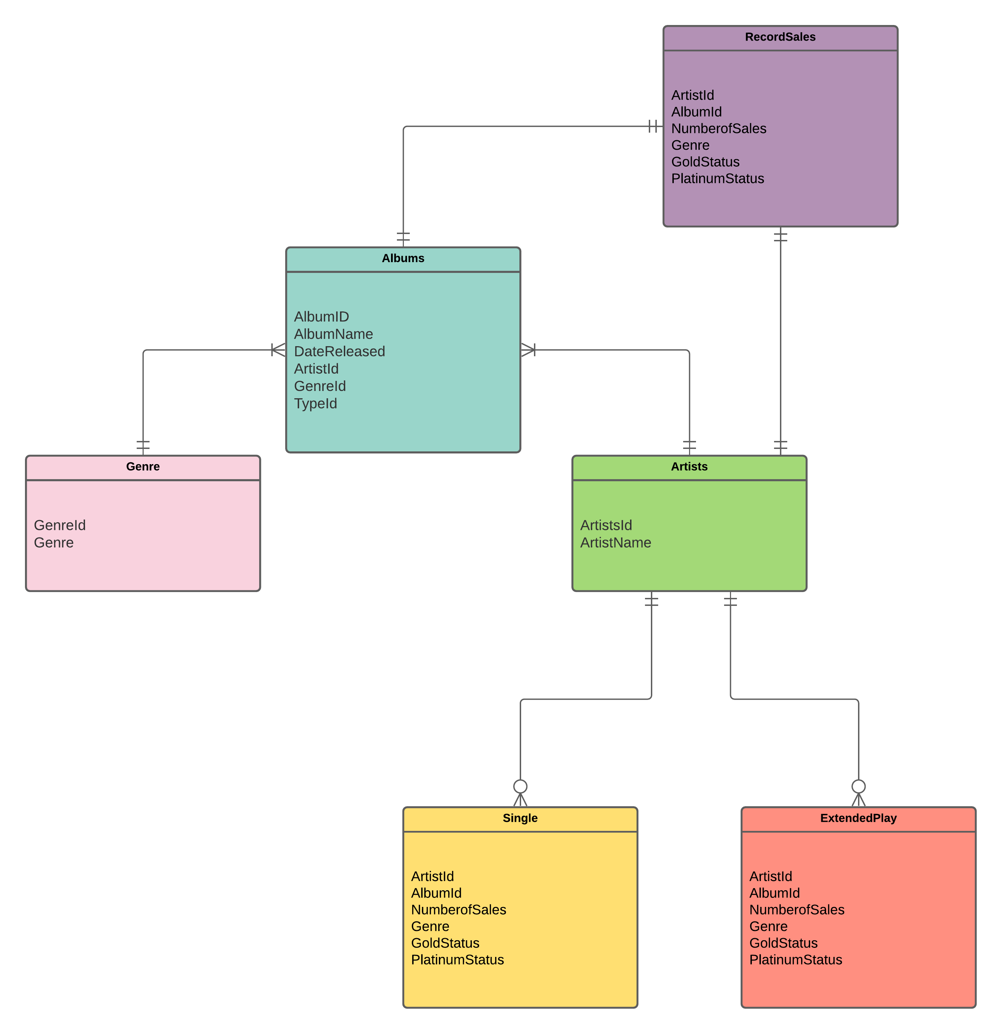

# References

Academy, A. (2019). "What is the difference between DBMS and RDBMS?". from <https://afteracademy.com/blog/what-is-the-difference-between-dbms-and-rdbms#:~:text=Data%20Access%3A%20Data%20is%20accessed%20faster%20in%20RDBMS,the%20query%20and%20get%20the%20required%20results%20accordingly>.

AHMED, I. (2019). "5 Best RDBMSs – A Comparison of Strengths and Weaknesses."

Branson, T. (2016). "8 Major Advantages of Using MySQL." from <https://www.datamation.com/storage/8-major-advantages-of-using-mysql/>.

Flair, D. (2020). "Amazon Aurora – 5 Unbelievable Benefits & Use Cases."

G2 (2021). "Compare Relational Databases Software." from <https://www.g2.com/categories/relational-databases>.

help, S. t. (2021). "Top 30 Most Popular Database Management Software: Complete List." from <https://www.softwaretestinghelp.com/database-management-software/>.

Nagy, Z. (2018). "Microsoft SQL Server Database Advantages And Best Practices." from <https://www.quickstart.com/blog/microsoft-sql-server-database-advantages-and-best-practices/>.

Singh, H. (2020). "Oracle Database Advantages, Disadvantages and Features [Guide 2021]." from <https://theninehertz.com/blog/advantages-of-using-oracle-database>.